Bit Stuffing

Problem:Framing Error



Solution: Bit stuffing

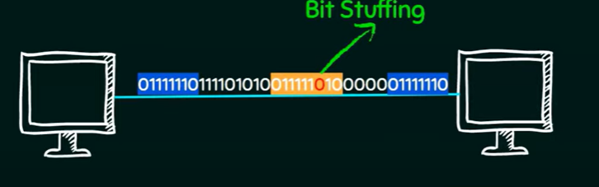

When the sender sends the data if it finds 6 consecutive 1s it will put a 0 after 5th 1. Receiver knows the ending sequence so it will check the bits to see if 5 consecutive 1s and 1 0 follows them; it converts the data and removes the 0.